MWEMBEZHI SECONDARY SCHOOL
CHEMISTRY LESSON PLAN
GRADE | TOPIC | SUB TOPIC | DURRATION | DATE
11 | Chemical reactions | activation energy and activated complex | ____min | ____/___/__

RATIONALE: The activated complex is a transitional structure in a chemical reaction that results from the eﬀective collisions between reactant molecules. This will help learners to determine how the reaction can be speeded up. Group/ pair work and demonstration will be used to execute the second lesson of five in the series.
SPECIFIC OUTCOMES, LSBAT: - Describe the effect of a catalyst on the activation energy
- Interpret graphical representations for rate of chemical reactions.
- Describe methods of controlling the rate of chemical reactions.
PRE-REQUISITE SKILLS : learners have knowledge on factors that affect the rate of
a chemical reactions.
TEACHING/ LEARNING AIDS : chemistry key point’s pupils book 11, periodic table.
REFFERENCES : chemistry 11, chemistry made clear. Certificate
Chemistry 4th edition.

LESSON PROGRESSION
STAGE | T/L ACTIVITY | LEARNING POINTS
INTRO-  DUCTION  ____min | Revise on how to measure the rate of a chemical reaction.
D  E  V  E  L  O  P  M  E  N  T  ____min | ACTIVITY 1  What is activation complex?  EXPLAIN THE FOLLOWING  it should be clear that most reactions will not take place until the system has some minimum amount of energy added to it. This energy is called the activation energy. Activation energy is the ’threshold energy’ or the energy that must be overcome in order for a chemical reaction to occur. It is possible to draw an energy diagram to show the energy changes that take place during a particular reaction. Let’s consider an example:  H2(g) + F2(g) → 2HF(g)  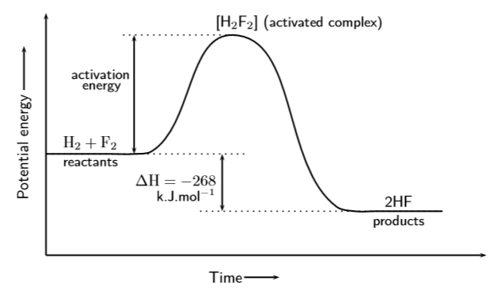 | The activated complex is a transitional structure in a chemical reaction that results from the eﬀective collisions between reactant molecules, and which remains while old bonds break and new bonds form.  explanation on the diagram  The reaction between H2(g) and F2(g) needs energy in order to proceed, and this is the activation energy. Once the reaction has started, an in-between, temporary state is reached where the two reactants combine to give H2F2. This state is sometimes called a transition state and the energy that is needed to reach this state is equal to the activation energy for the reaction. The compound that is formed in this transition state is called the activated complex.
C  O  N  L  U  S  I  O  N  ____min | Go through the main points

EVALUATION: ……………………………………………………………………………………………………………………………………………………………………………………………………………………………………………………………………………………………………….

